DATE: 07.02.2020
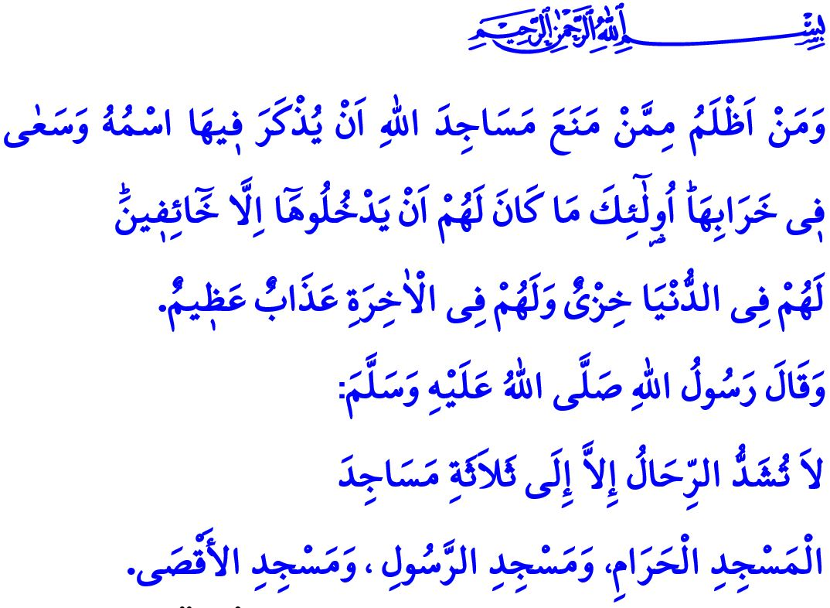
AL-QUDS (JERUSALEM) IS AN ISLAMIC LAND AND BELONGS TO ISLAM
Honorable Muslims!
One day Prophet Muhammad's wife Maymunah asked him, "Tell us something about Bayt al-Maqdis." He (saw) said, "That is the place of resurrection. Go and pray there! For one prayer performed there is like one thousand prayers performed elsewhere.” When she asked him, "What if I cannot travel and go there?", he replied, "Then send a gift of olive oil to light its lamps. For whoever does that is like one who goes there.”
Dear Believers!
Al-Quds is a universal value that bears witness to the most deeply-rooted human heritage. It is the symbol of a stance that reflects faith, a direction that is aligned with the divine revelation, and a turn towards affection. It is an Islamic city, home to countless memories of many prophets. The first qibla of Muslims, al-Masjid al-Aqsa, is there. In the hadith I recited as I began the khutbah, Prophet Muhammad (saw) says, "Mounts are not saddled for except to travel to three masjids for worship: Al-Masjid Al-Haram, this Masjid of mine, and al-Masjid Al-Aqsa."
Dear Muslims!
Al-Quds is referred to as "dar al-salam (Jerusalem)", namely the land of peace. Al-Quds has been the symbol of freedom and justice under the Muslim rule for centuries. It was ruled as a land on which not only Muslims but also all people of any faith could freely perform their worships and live in peace.
Since its invasion and occupation, however, al-Quds has lost its peaceful and tranquil atmosphere. Al-Quds is woeful. Overshadowed by conflicts, insults, and oppression, al-Masjid al-Aqsa is in sorrow. This occupation actually targets the unity, solidarity, and sacred values of Muslims. It prevents Muslims from worshipping in their own land and in their own mosques. However, in the Holy Qur'an it is stated of those who damage the masjids of Allah and prevent Muslims from worshipping, "And who are more unjust than those who prevent the name of Allah from being mentioned in His mosques and strive toward their destruction. It is not for them to enter them except in fear. For them in this world is disgrace, and they will have in the Hereafter a great punishment."
Dear Believers!
To occupy Palestine and al-Quds means actually to prevent peace not only in the region but also across the world by creating chaos. To fuel the turmoil and feed on war-waging means actually to turn one's back on mercy, conscience, and compassion. To force Muslims out of al-Quds, a city that has throughout the history embraced all humanity, means actually to disregard the laws, rights and honor of all humanity.
As the cry-outs of the oppressed people reach the clouds, the only solution is for Prophet Muhammad's ummah to come together and stand against the oppression and occupation. For only when they unite their faithful stances and capabilities, Muslims will form the fairest and most merciful force in the world. They will be the shared hope of all humanity that is in search of fairness and trust. Let us not forget that, for Prophet Muhammad's ummah, al-Quds is an opportunity to save Muslims' untouchable land and their distorted unity. Al-Quds is also the cause for rendering prosperous the devastated life in the world, in all quarters of which run blood and tear.
Honorable Muslims!
Jerusalem (al-Quds) is an Islamic land and belongs to Muslims. Our honorable nation has a deep love for al-Quds and takes Masjid al-Aqsa dearer than their own life and property. Just as in the past, today, too, the helping hand of our nation is extended out for our oppressed Palestinian brothers and sisters who have for years been safeguarding the Masjid al-Aqsa.

Ibn Majah, Iqamah, 196; Abu Dawud, Salat, 14.
Bukhari, Fadhl al-Salat, 1.
Baqarah, 2/114. General Directorate of Religious Services

